**San Francisco Bay University**

**MATH201 - Calculus-I**

**Homework Assignment #1**

**Due day: 5/27/2023**

**Instruction:**

1. **Push the answer sheet to Github in Word file.**
2. **Overdue homework submission can’t be accepted.**
3. **Takes academic honesty and integrity seriously (Zero Tolerance of Cheating & Plagiarism)**
4. Researchers measured the blood alcohol concentration (BAC) of eight adult male subjects after rapid consumption of *30* mL of ethanol (corresponding to two standard alcoholic drinks). The table shows the data they obtained by averaging the BAC (in mgymL) of the eight men.
   1. Use the readings to sketch the graph of the BAC as a function of *t* in Excel.
   2. Use your graph to describe how the effect of alcohol varies with time.

|  |  |
| --- | --- |
| ***t* (hours)** | **BAC** |
| 0 | 0 |
| 0.2 | 0.25 |
| 0.5 | 0.41 |
| 0.75 | 0.40 |
| 1 | 0.33 |
| 1.25 | 0.29 |
| 1.5 | 0.24 |
| 1.75 | 0.22 |
| 2.0 | 0.18 |
| 2.25 | 0.15 |
| 2.5 | 0.12 |
| 3.0 | 0.07 |
| 3.5 | 0.03 |
| 4.0 | 0.01 |

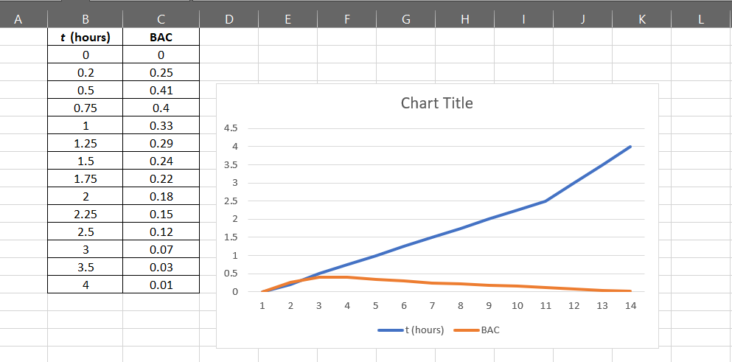

The graph indicates that the BAC initially rises and then falls steadily after taking alcohol. And as time passes, the body removes the alcohol.

1. Find an expression for the function whose graph is the given curve in the top half of the circle $x^{2}+ {(y-2)}^{4}=4$, and then plot it in Excel or any computer language.

Answer: x^2 + (y - 2)^4 = 4

*When we subtract x^2 from both sides:*

(y - 2)^4 = 4 - x^2

*We take the fourth root of both sides:*

y - 2 = 2^{1/4} * \pm (2 - x^2)^{1/4}

*We add 2 to both sides:*

y = 2 + 2^{1/4} * \pm (2 - x^2)^{1/4}

*We take the positive sign on the right side and that will give the function whose graph is the top half of the circle:*

y = 2 + 2^{1/4} * (2 - x^2)^{1/4}

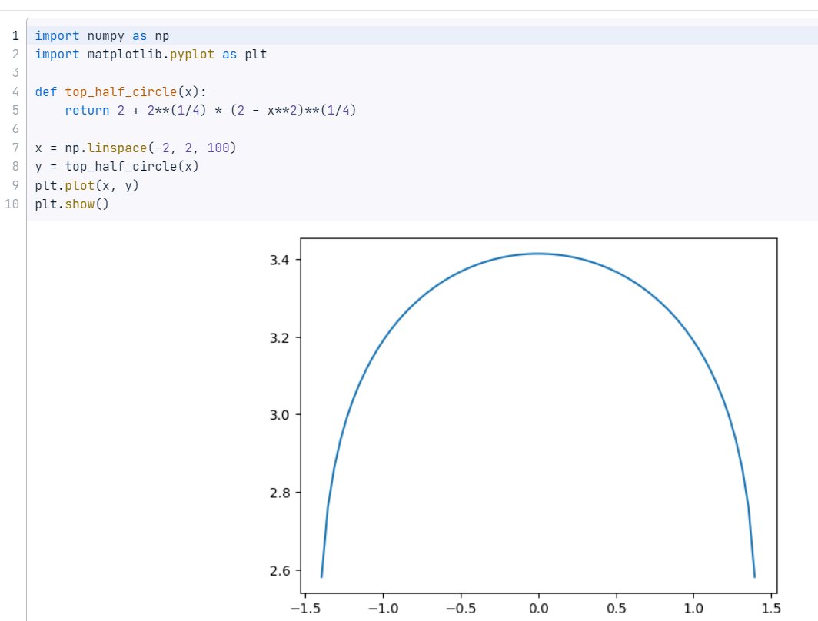Python code to graph:

1. In a certain country, income tax is assessed as follows. There is no tax on income up to *$10,000*. Any income over *$10,000* is taxed at a rate of *10%*, up to an income of *$20,000*. Any income over *$20,000* is taxed at *15%*.
   1. Sketch the graph of the tax rate *R* as a function of the income *I* in Excel
   2. How much tax is assessed on an income of *$14,000*? On *$26,000*?
   3. Sketch the graph of the total assessed tax *T* as a function of the income *I* in Excel.

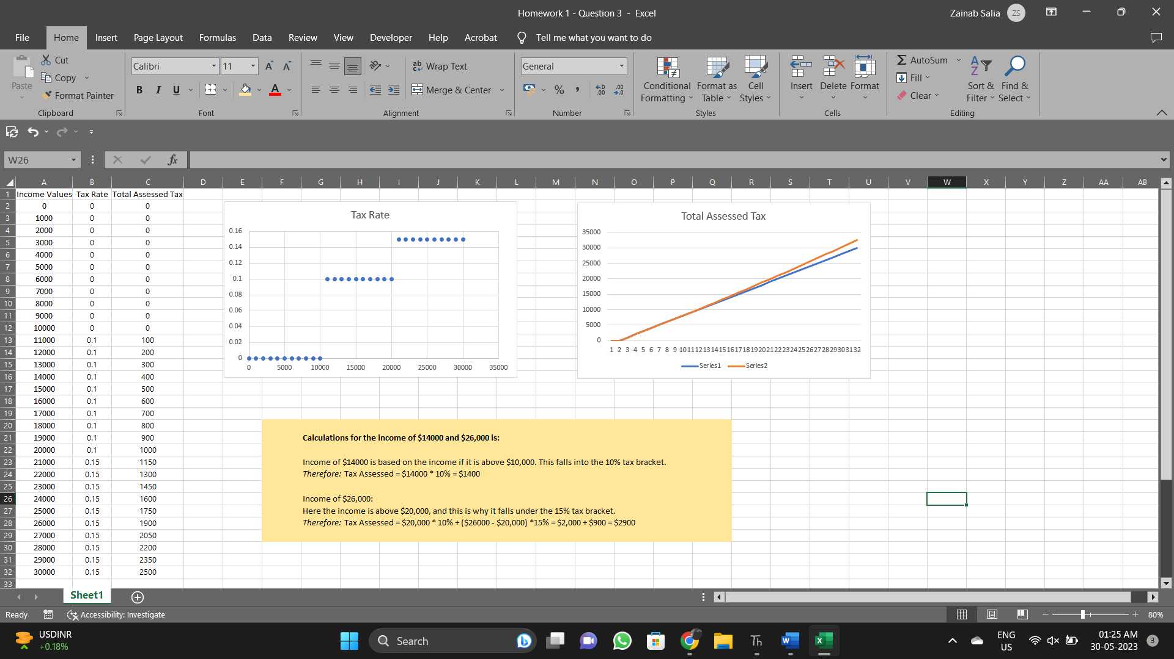

1. Decide what type of function you might choose as a model for the given data as follows by selecting fitting function in Excel. Of course, before fitting, the x-y values should be created based on your observation.

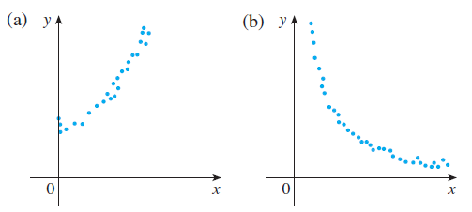

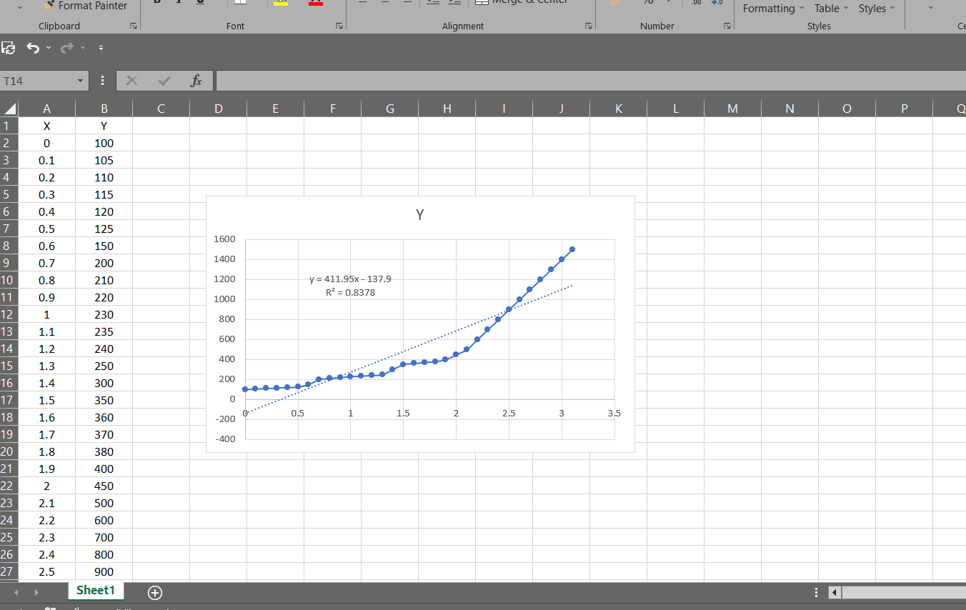

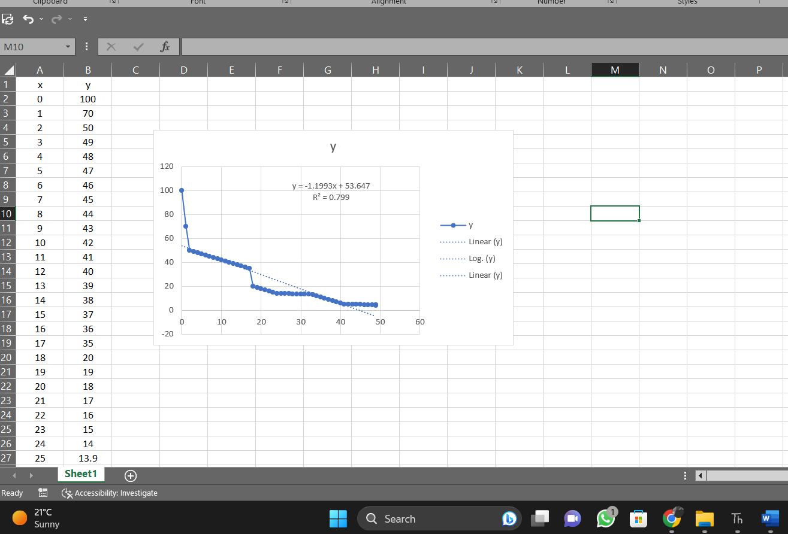

1. Anthropologists use a linear model that relates human femur (thighbone) length to height. The model allows an anthropologist to determine the height of an individual when only a partial skeleton (including the femur) is found. Here we find the model by analyzing the data on femur length and height for the eight males given in the following table.
   1. Make a scatter plot of the data in Excel.
   2. Find and graph the regression line that models the data.
   3. An anthropologist finds a human femur of length *53* cm. How tall was the person?

|  |  |
| --- | --- |
| **Femur length**  **(cm)** | **Height**  **(cm)** |
| 50.1 | 178.5 |
| 48.3 | 173.6 |
| 45.2 | 164.8 |
| 44.7 | 163.7 |
| 44.5 | 168.3 |
| 42.7 | 165.0 |
| 39.5 | 155.4 |
| 38.0 | 155.8 |

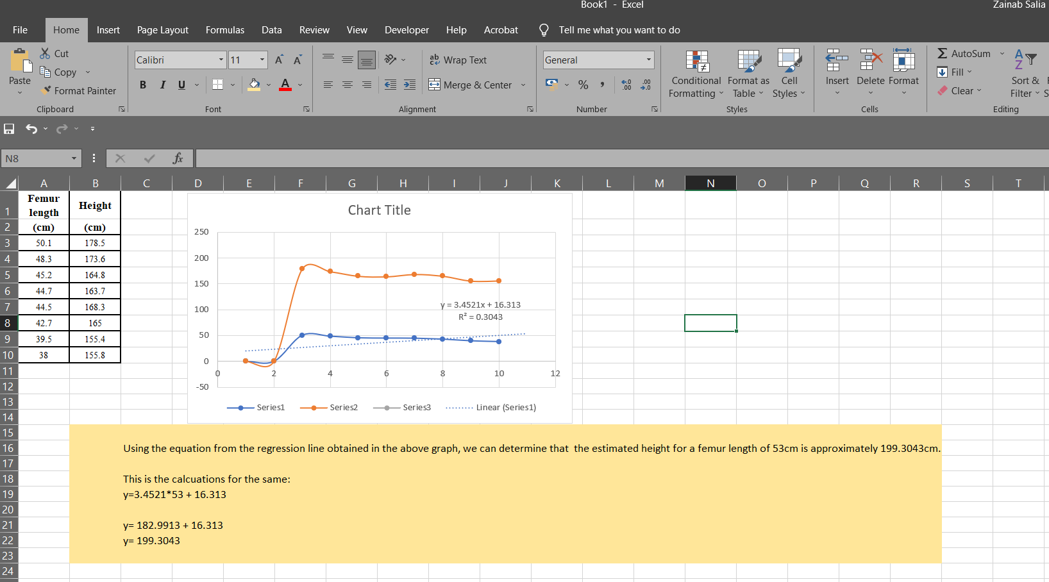

1. The table shows the mean (average) distances *d* of the planets from the sun (taking the unit of measurement to be the distance from the earth to the sun) and their periods *T* time of revolution in years).
   1. Fit a power model to the data in Excel
   2. Kepler’s Third Law of Planetary Motion states that "The square of the period of revolution of a planet is proportional to the cube of its mean distance from the sun."
   3. Does your model corroborate Kepler’s Third Law?

|  |  |  |
| --- | --- | --- |
| **Planet** | **d** | **T** |
| Mercury | 0.387 | 0.241 |
| Venus | 0.723 | 0.615 |
| Earth | 1.000 | 1.000 |
| Mars | 1.523 | 1.881 |
| Jupiter | 5.203 | 11.861 |
| Saturn | 9.541 | 29.457 |
| Uranus | 19.190 | 84.008 |
| Neptune | 30.086 | 164.784 |
|  |  |  |

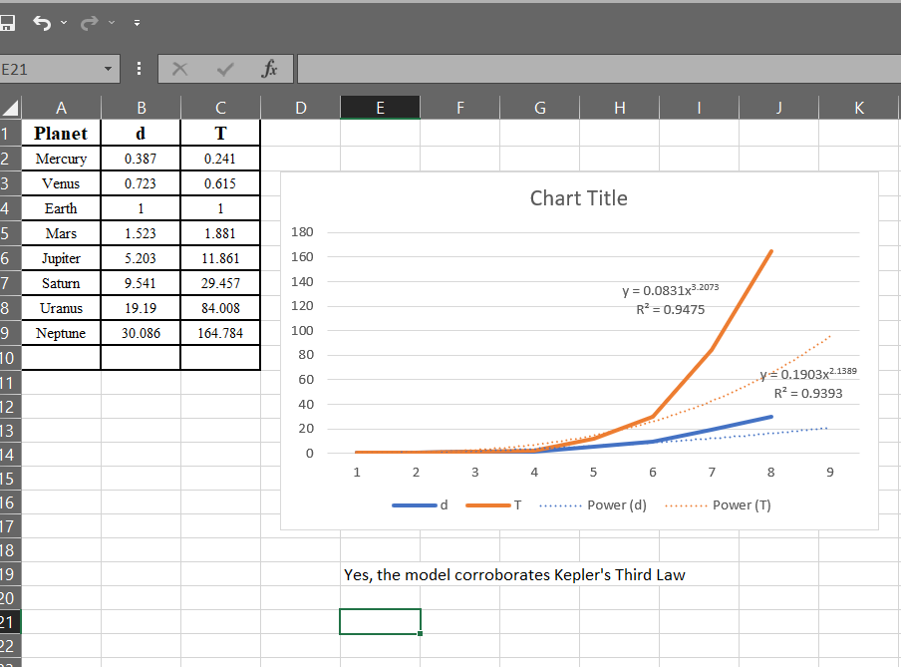

1. How is the graph of $y=f(|x|)$ related to the graph of *f(x)?*
   1. Sketch the graph of $y=sin(|x|)$ in Excel.

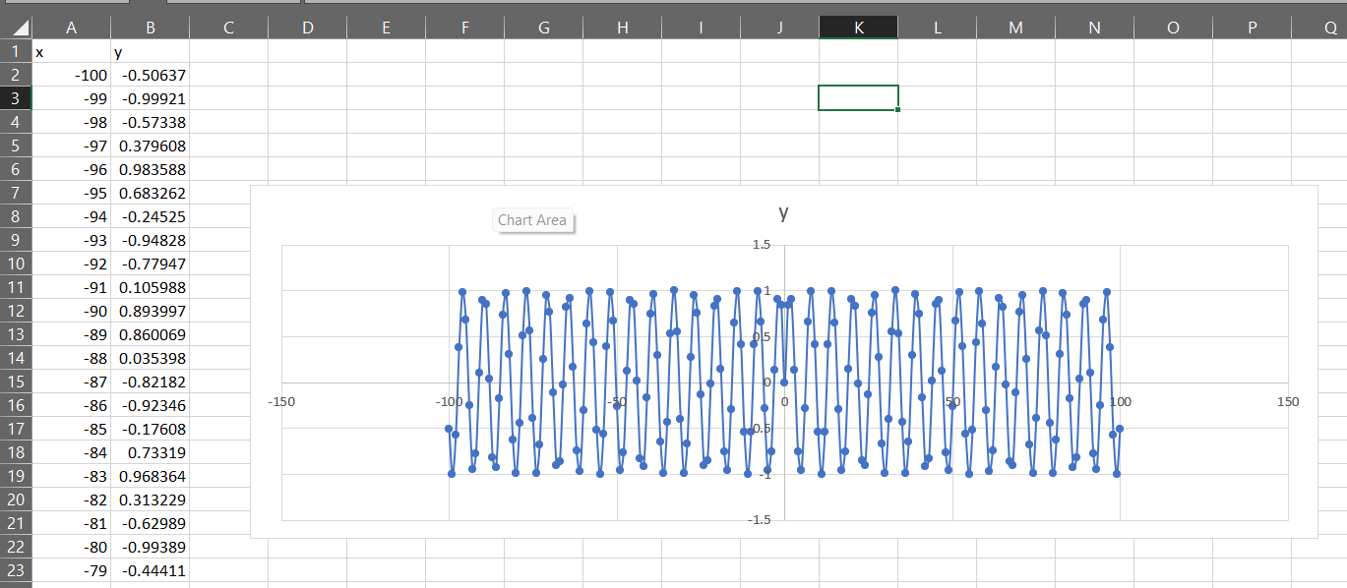

* 1. Sketch the graph of $y=\sqrt{|x|}$ in Excel.

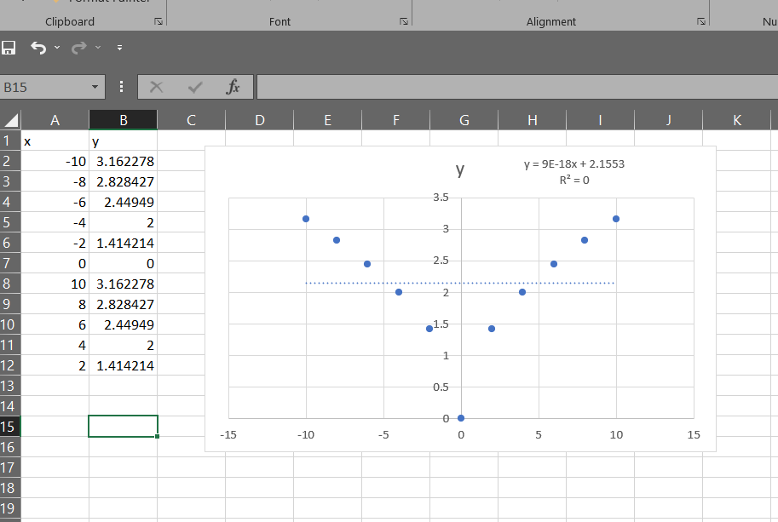

1. Use the given graphs of *f* and *g* to evaluate each expression or explain why it is undefined.
   1. $(g ○ f) (6)$- undefined because the graph has no point of 6

b. $(g ○ g) (-2)$- -2

c. $(f ○ f) (4$)

